SAMPLE COVER PAGE:
School Name: New School, International School of Georgia 2014-15
Name of Student: Angelina Jolie
Grade Level: MYP5 (Grade 10)

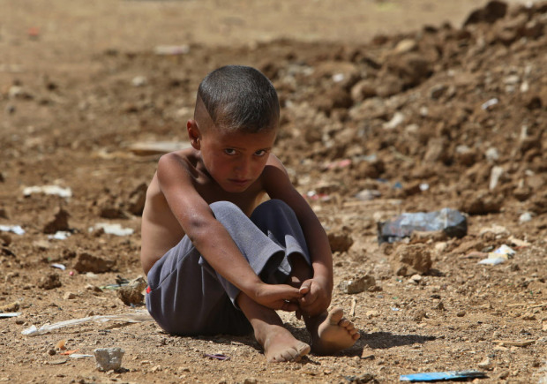

Fullcomment.nationalpost.com

Title of the project:
Innocence Lost:
Understanding and raising awareness of the scale and complexity of Syria’s displacement crisis, with particular reference to children aged from 0 to 10 years old.

Supervisor: Mr B. Pitt Word Count: 3240

