**Using a Process Journal**

**What does it look like?**

C:\Documents and Settings\Administrator\Local Settings\Temporary Internet Files\Content.IE5\Q829402F\MC900364642[1].wmf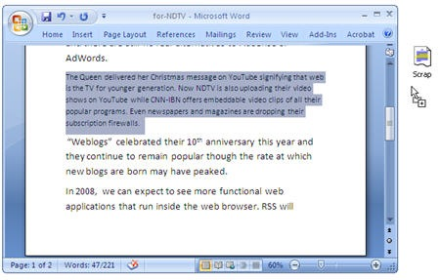C:\Documents and Settings\Administrator\Local Settings\Temporary Internet Files\Content.IE5\3T3Q7JRH\MC900230425[1].wmf

A website A scrap book

C:\Documents and Settings\Administrator\Local Settings\Temporary Internet Files\Content.IE5\3T3Q7JRH\MC900234083[1].wmf

A notebook A word document

A wiki

or blog

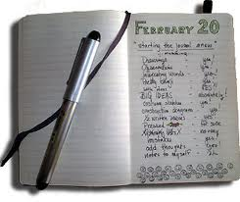 Images : Microsoft. (Producer). 00037104.wmf. [Web]. Retrieved as clip art,

www.labnol.org

A journal

You are not restricted to any single model of recording their process journals. The journal can be presented in different formats, depending on student preferences. It could be in written, visual, audio or a combination of these, formats. It could be on paper or in an electronic format. If a student uses electronic/digital media, then they should make and maintain copies of their journals.

**Choose the format that you feel will be the most effective for your style of learning and make it work for you.**

**What to include in a Process Journal**

Record progress in this journal using: brainstorm ideas, notes and drawings, reflections on your ideas, successes, obstacles and hurdles you encounter, and any other information that you think is relevant to your project. The journal will be organized, chaotic, tidy and messy, because you will be putting complete and incomplete pieces of work into it.

Use the journal to keep:

* Notes and ideas on the project area of interaction
* Concepts for the project
* Drawings, pictures, clippings, photographs
* Information gathered from investigations
* Copies of interviews and discussions with people
* Plans for the project
* Timeline(s)
* Entries into the journal should be organized by entry number, the date they were entered, performed, created, or reflected upon.
* Make regular entries to reflect on the ideas, the process, resources, good and bad experiences and challenges.
* Show evidence of regular use of the Process Journal.
* Quality of thinking is more important than neatness and presentation
* Make a **To-Do-List**—here you list what you need to do next and before meeting with your supervisor.
* The journal notes are used to write up the report and present the product in the exhibition.
* This journal will be used throughout the process and should incorporate the ATL’s.
* Make sure that you produce evidence that shows you have addressed the four objectives to demonstrate your achievement at the highest levels of the criteria.
* **Your journal will be assessed through Criterion A**
* **Remember: the journal will be the most important document in the Personal Project experience because from it you will be able draw all the kind of information needed to write up the report.**

Below are suggestions on how you might want to plan journal entries:

* **Work Completed This Week**—this section should detail everything done in the Personal Project that week.
* 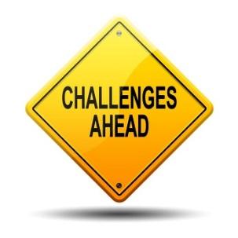**Resources/Bibliography Referred to** —in this section record all of the bibliographical information that might be required. As research and location of sources continues, it should prove useful to record the bibliographic details. It may be that later on a particular reference source is not necessary but it is better to be able to delete a reference than to try and find it again. Remember that all conversations with experts dealing with your project should be recorded, as well as basic book and Internet resource information.
* **Challenges/Obstacles**—what issues arose during the project process. It is vital to record this information to show how you dealt with obstacles and adapted your methods.
* **Evaluation of the Process and Progress**—here, you should state what your original plans and goal(s) were for the Personal Project and how you achieved or did not achieve your original goals. It is okay for you not have met your goal(s), but you should clearly identify the issues that arose and what made it difficult for you to achieve your goal(s).

|  |  |
| --- | --- |
| **The Process Journal Is:** | **The Process Journal Is not:** |
| * used throughout the project to document its development * an evolving record of intents, processes, accomplishments * a place to record initial thoughts and developments, brainstorming, possible lines of inquiry and further questions raised * a place for recording interactions with sources, for example teachers, supervisors, external contributors * a place to record selected, annotated and/or edited research and to maintain a bibliography * a place for storing useful information, for example quotations, pictures, ideas, photographs * a means of exploring ideas and solutions * a place for evaluating work completed * a place for reflecting on learning * devised by the student in a format that suits his or her needs * a record of reflections and formative feedback received. | * used on a daily basis (unless this is useful for the student) * written up after the process has been completed * additional work on top of the project; it is part of and supports the project * a diary with detailed writing about what was done * a static document with only one format. |