New School Code of Conduct
The New School Code of Conduct, which is in line with the IB Learner Profile, is a positive means of encouraging appropriate behavior. It includes five statements. These are written in a positive manner, and represent the desired behaviors and habits that students are expected to model and practice on a daily basis. We will consistently challenge students to consider their behavior and contributions to school life in terms of the Code of Conduct.

Upper School Code of Conduct

    - Be truthful; communicate honestly.
    - Be actively engaged in learning; ask questions, listen to others, work together.
    - Be caring, friendly, helpful and polite to others.
    - Be responsible for personal property and for the property of others.
    - Be respectful and sensitive to the needs of others.
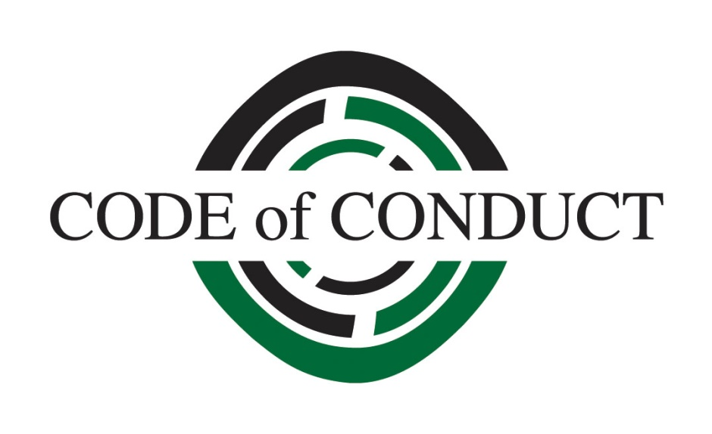

www.hrk.de

