Writing the Project Report (2)
The MYP personal project report demonstrates your learning throughout your project. Reflection and self-evaluation are a key component of your process journal entries and should be reflected in your project report.
Some key questions to consider:
How has subject-specific learning and the transfer of this learning impacted your project?
What have you discovered in relation to the project goal and the global context?
How have you developed as a learner, specifically your awareness and development of ATL skills?
All these questions SHOULD be answered in your report
The following subheadings are suggestions that could be used when writing your report.
Use these questions as a guide to what you could include in each area.

Investigating
- What was your SMART goal? (SMART: specific, measurable, attainable, relevant, time-based)
- What is your goal and have you explained it clearly?
- Is your goal a highly challenging one? What made it so?
- How did your personal interests influence the selection of your goal?
- What is your global context? Why did you select this global context?
- How are your goal and the global context linked?
- What relevant previous knowledge did you have on the subject?
- What new understandings did you gain from your research?
- What types of sources did you use?
- How did you know they were credible sources? Accurate? Relevant? Objective?
Planning
- What were your criteria?
- Why and how did you select your criteria?
- What makes your criteria specific and rigorous?
- Explain the step-by-step process, as well as the timeline that you used to complete your project.
- Refer to specific process journal extracts you will include in your appendix that supports your comments in the report.
- Did you manage your time and resources effectively?
- What obstacles did you experience?
- How did you overcome these obstacles?

Taking Action
- Describe the product/outcome that you created.
- How does your product/outcome reflect the SMART goal that you developed?
- How does your product/outcome reflect the global context you selected?
- Why did you choose to express your learning through your product/outcome?
- With whom did you collaborate during your project? Were they useful or not?
- How does your product/outcome reflect new ideas and different perspectives?
Reflecting
- How does your product/outcome meet each criterion that you developed?
- How can you transfer your newly learned knowledge to other parts of your life?
- How has completing the project extended your knowledge and understanding of your topic?
- How has completing the project extended your knowledge and understanding of the global context you selected?
- Which IB Learner Profile Attributes did you develop during the project?
- What would you do differently if you had the opportunity to do the project over again? Why?

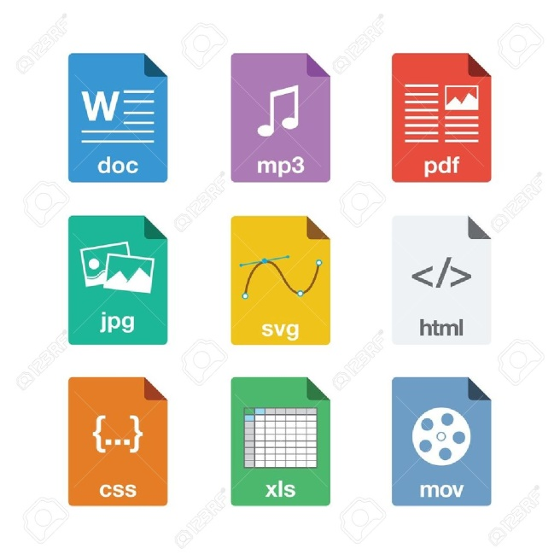
Possible formats for the MYP personal project report are divided into four main areas: written, electronic, oral and visual.

Format Length
Written…1,500 - 3,500 words

Electronic…website, blog, slide
show) 1,500 - 3,500 words

Oral…podcast, radio broadcast, recorded
13 - 15 minutes

Virtual (film) 13 - 15 minutes

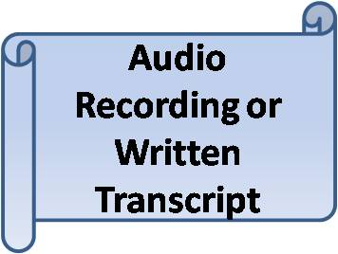
If students submit a multimedia report both written and audio/visual formats, the maximum number of words and time are:

Time: 3 minutes AND 1,200-2,800 words
Time: 6 minutes AND 900-2,100 words
Time: 9 minutes AND 600-1,400 words
Time: 12 minutes AND 300-700 words

